**ASSIGNMENT-4**

**Harsh Chandrakar PRN-250840125020**

Q 1. Create a class 'Student' with rollno, studentName, course ,dictionary of

marks(subjectName -> marks [5]). Provide following functionalities

A. initializer

B. override __str__ method

C. accept student data

D. Print student data for given id.

E. Print Student who has failed in any subject.

Write menu driven program to test

above functionalities.( accept records of 5 students and store those in list )

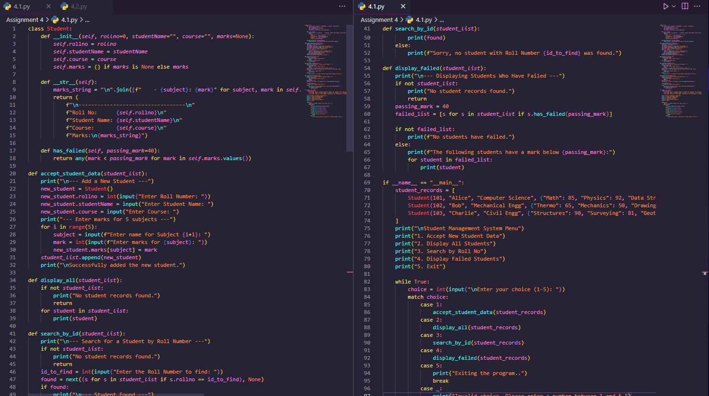



2. Write a menu driven program to maintain student information. for every student

store studetid, sname, and m1,m2,m3 marks for 3 subject. also store gpa in

student list, add a function in student class to return GPA of a student

- Calculate GPA()

gpa=(1/3)*m1+(1/2)*m2+(1/4)*m3

Create list to store Multiple students.

1. Display All Student

2. Search by id

3. Search by name

4. Calculate GPA of a student

5. Exit

